**Gerald “Bummy” Burstein**

**Auditorium Foyer**

Dedicated to

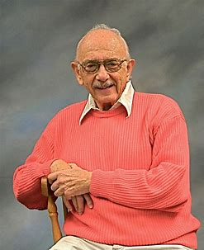

**Gerald “Bummy” Burstein, ‘43**

**December 29, 1926 – August 31, 2018**

**“There is no school like ours...and no alumni like ours!   
Magnificent, super, marvelous, and all kinds of adjectives   
come to mind when I think of our beloved school.”**

*Excerpt from a letter in the 110th Anniversary Celebration of “47” Journal*

As anyone who knew Gerald “Bummy” Burstein, Bummy provided extraordinary leadership within the Deaf community. A tireless advocate, leader, teacher, and inspiration, Bummy was outstanding in his dedication to and love of Deaf children and adults all over the world.

**Presented by “47” Alumni Association of the Deaf, Inc.**

**May 21, 2019**

